CSC · CMMI ML 5.0 (DEVELOPMENT) AND ML 3.0 (SERVICES)
CMMI Data Repository
Data flow and entity relationships, drawn from the running schema and the route handlers rather than from an intended design.
Row counts as at 9 October 2026.

1. Context diagram
Who hands the system something, and what they get back. One process at this level; everything inside it is the next diagram.
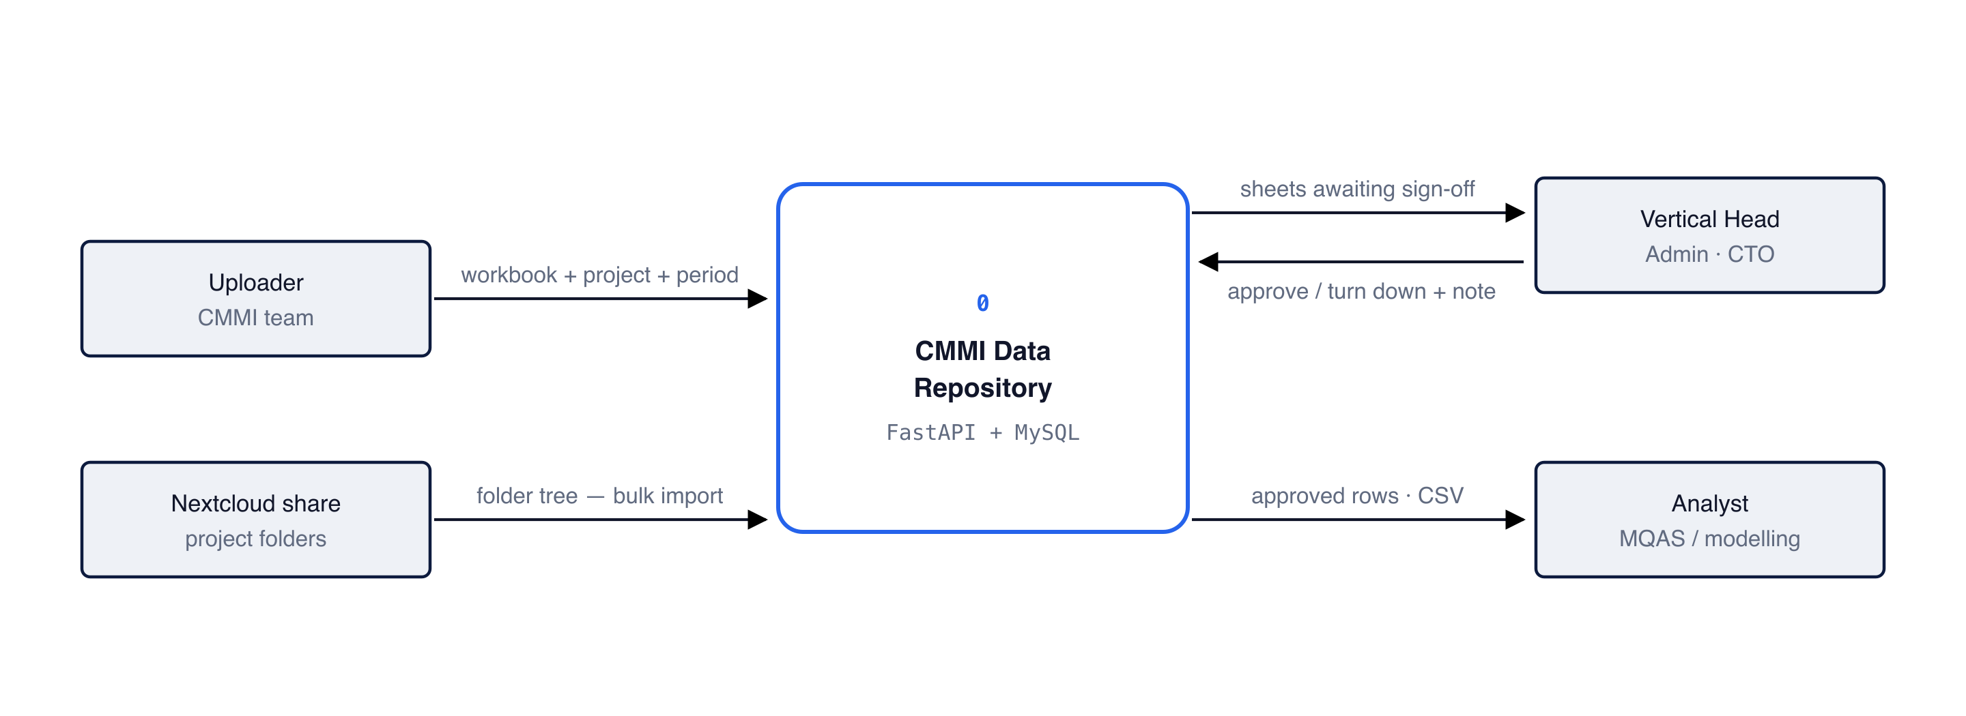
Figure 1. Approved rows are the only thing that leaves. Browse and CSV export filter on stage = 'approved', so a sheet sitting at any of the three approval stages is invisible to the analyst even though its rows are already stored.

2. Level 1 — what happens to a workbook
The path from a file on someone's laptop to a row an analyst can query. Each process writes to its own store; nothing is thrown away along the way.
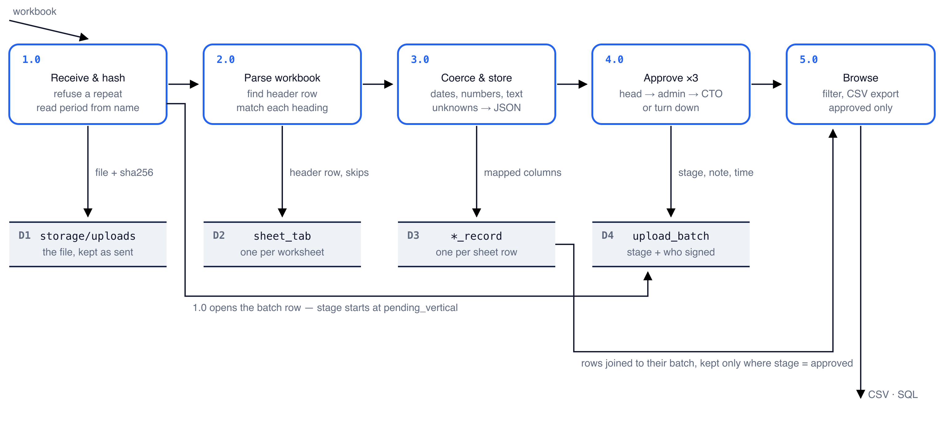
Figure 2. Rows are written at step 3, before anyone approves anything — approval only flips a column on upload_batch. That is why step 5 has to join back to the batch: the rows themselves carry no approved flag, so the join is what keeps unapproved data out of an export.

3. The approval chain
One stage column on upload_batch moves through four values. Each stage belongs to exactly one role, so no one can sign twice — an administrator cannot also give the vertical head's approval.
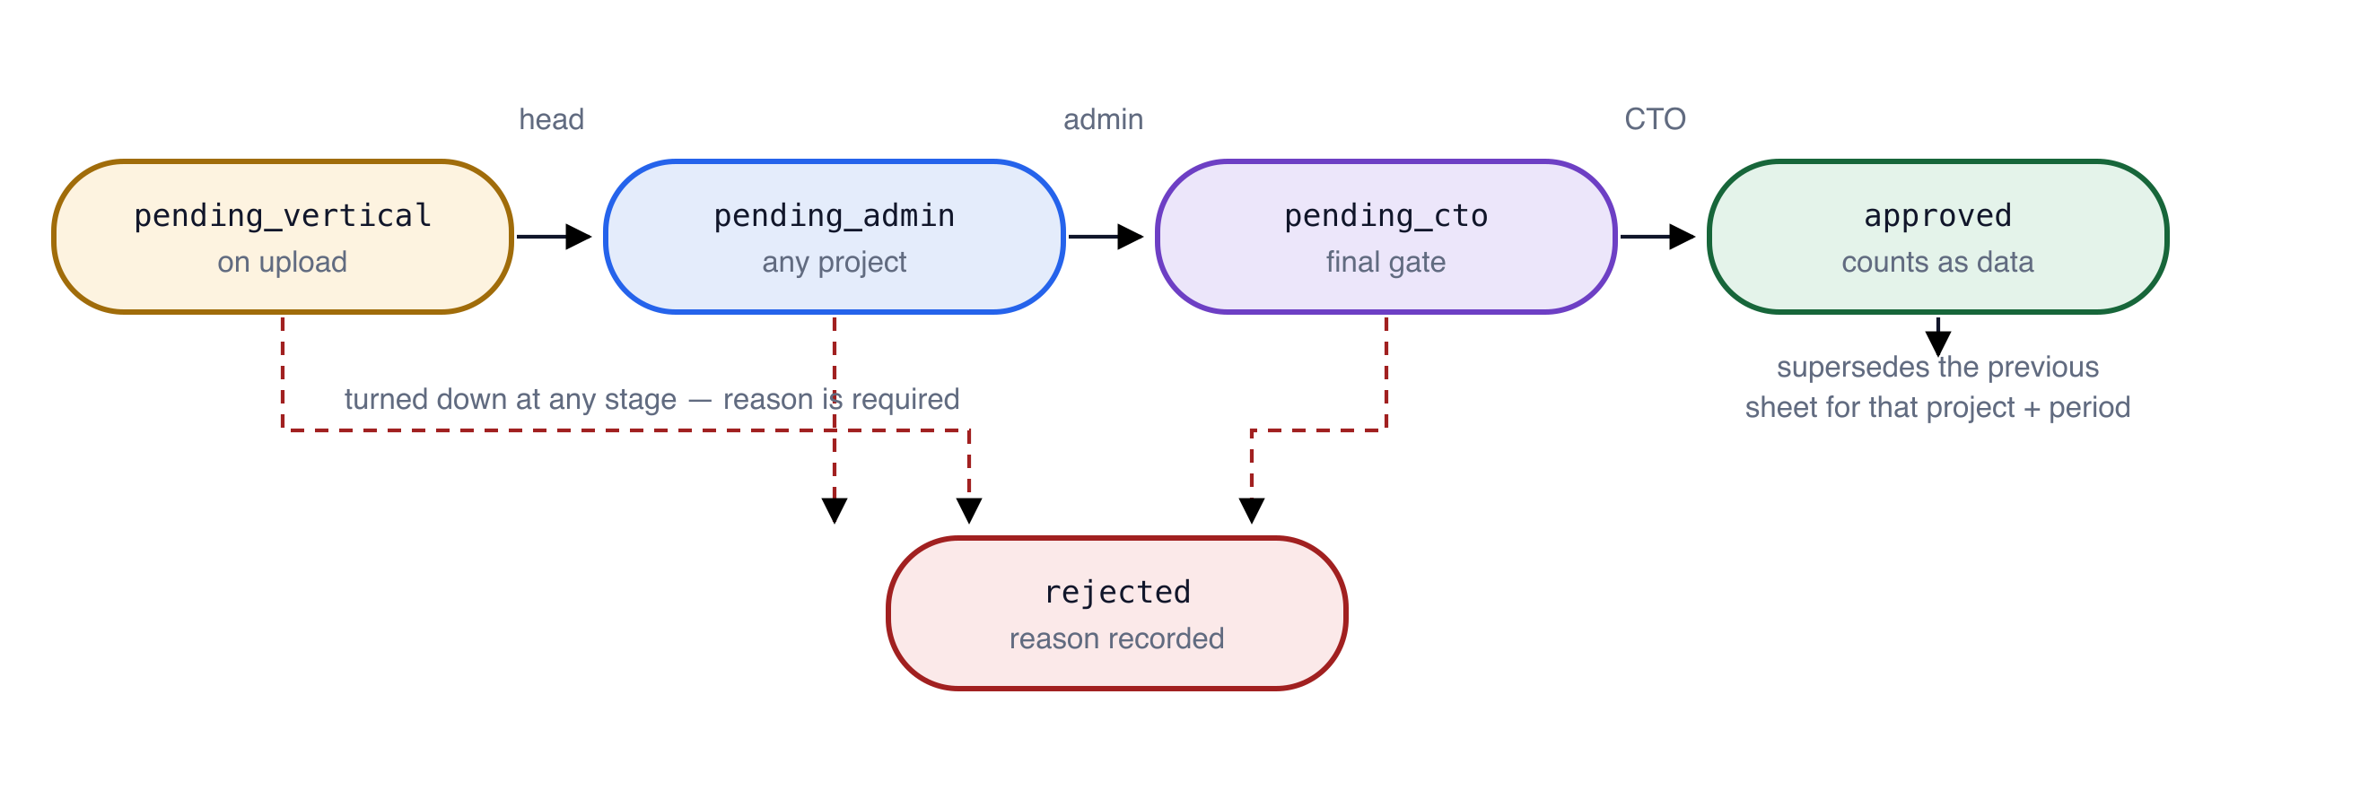
Figure 3. There is no path back from rejected. A turned-down sheet is corrected outside the system and uploaded again as a new batch, which is why the rejection reason is kept on the old row rather than cleared.
A sheet reaching approved marks any earlier sheet for the same project and period as superseded rather than deleting it.

4. Entity relationships
Eleven tables. The three reference tables on the left are seeded once by scripts/init_db.py; everything to the right of them is written by an upload.
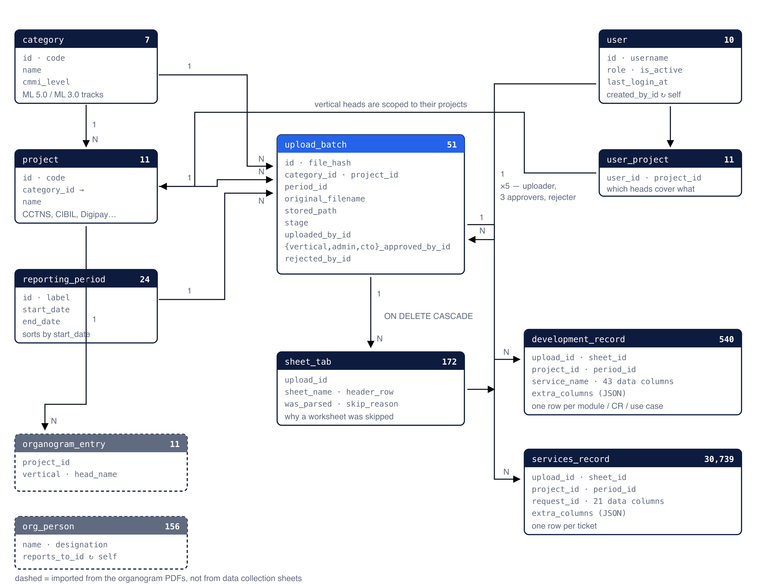
Figure 4. Both record tables carry project_id and period_id even though upload_batch already has them. That is deliberate denormalisation — it lets a modelling query group 30,739 service rows by period without a join.

5. Tables as they stand
Row counts taken from the running database.
TABLE | ROWS | HOLDS
category | 7 | The two active tracks plus five further ML 3.0 views of the model
project | 11 | Six Development projects, five Services projects
reporting_period | 24 | Cycles and months, with real start and end dates
user | 10 | Sign-ins: one admin, one CTO, seven vertical heads, one shared uploader
user_project | 11 | Which projects each vertical head covers
upload_batch | 51 | One uploaded workbook: who, when, hash, stage, every sign-off
sheet_tab | 172 | Each worksheet, its header row, or why it was skipped
development_record | 540 | One row per module / CR / use case — 43 data columns
services_record | 30,739 | One row per ticket — 21 data columns
organogram_entry | 11 | Vertical and head per project, from the organogram files
org_person | 156 | The reporting tree, self-referencing through reports_to_id

6. Four things the diagrams imply
• There is no activity or audit table. The Activity page is derived at request time from the timestamp columns on upload_batch and user — one batch row produces up to five dated events. Those columns are the record of truth, so the trail cannot drift from what it describes.
• Deleting an upload deletes its history. sheet_tab and both record tables cascade from upload_batch, and the batch row carries the approvals, so a DELETE removes the upload, its rows and its sign-offs together. Only an administrator can delete.
• Row identity is the file plus the row's own name. service_name for Development, request_id for Services. Both pairs are indexed but neither is unique: Request IDs genuinely repeat in the Services logs, so a unique key would reject real rows.
• Nothing is discarded on the way in. A heading the catalogue does not recognise goes to extra_columns as JSON and is flagged on the upload page; a worksheet that is not a data collection sheet still gets a sheet_tab row recording why it was skipped.
Drawn from app/models.py, app/ingest.py and app/main.py, with row counts and foreign keys read from the live MySQL schema. Source diagrams: docs/*.svg in the repository.

